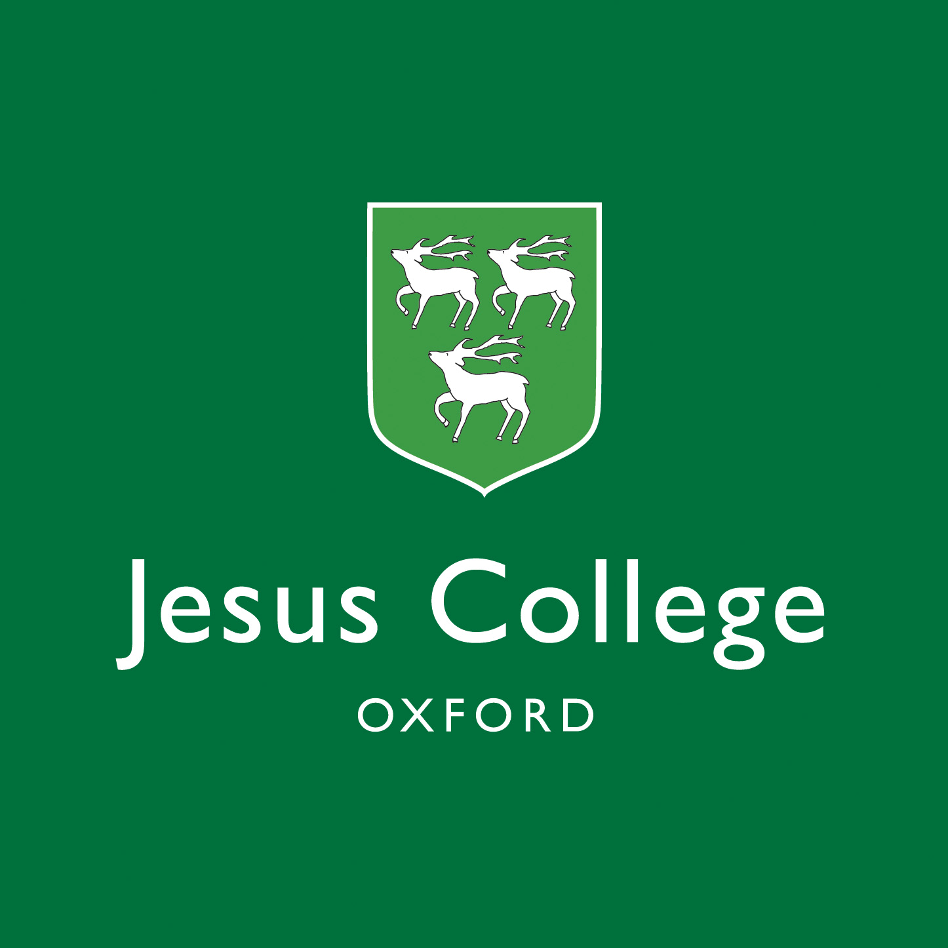

**Jesus College Junior Members’ Scholarship 2017**

**Further Details**

Jesus College Oxford is delighted to invite applications for its second Junior Members’ Scholarship from those wishing to study for an undergraduate degree at the University of Oxford commencing in October 2017. This Scholarship is being offered to a student in the Gaza Strip. This fully-funded Scholarship is funded through the generosity of undergraduate and postgraduate students at the College, the Governing Body of Jesus College, the Hoping Foundation and the A.M. Qattan Foundation. The Scholarship is a student-led initiative which aims to provide a talented undergraduate with the opportunity to study for a degree without disruption, so that they can achieve their full academic potential. It is expected that the Scholarship recipient will return to Gaza after graduating.

**Jesus College**

Jesus College was founded in 1571 by Elizabeth I and is one of the 38 constituent colleges which form the University of Oxford. The College admits just over 100 undergraduates every year and the student body consists of around 350 undergraduates and 200 postgraduates all studying for Oxford University degrees. We offer a superb academic environment promoting excellent in learning, teaching, and research and a vibrant, supportive and inclusive community. The College is located in the heart of historic Oxford and houses an excellent library as well as other facilities and resources including sports grounds. We offer all our undergraduates College accommodation for the duration of their degree and we also have generous grants and prizes.

Further information about the College may be found at:

<http://www.jesus.ox.ac.uk>

Further information regarding the University may be found at:

<http://www.ox.ac.uk/>

**What does the Scholarship cover?**

The Scholarship covers:

* full tuition fee (currently worth £15,295 and £22,515 per annum depending on course)
* full College fee (currently worth £7,135 per annum)
* full maintenance award (expected to be around £14,494 in 2017-18). This amount is sufficient to cover accommodation and food costs as well as other general living costs
* one return flight per year up to a maximum value of £500 per annum

**What Course May I Apply For?**

Applicants may apply for any three or four-year course which Jesus College offers at undergraduate level except for Medicine.

We offer the following courses which applicants may apply for:

* Biological Sciences
* Chemistry
* Classics; Classics and English; Classics and Modern Languages
* Economics and Management
* Engineering Science
* English Language and Literature; English and Modern Languages
* Experimental Psychology; Psychology, Philosophy & Linguistics
* Geography
* History; History & Economics; History & English; History & Modern Languages; History & Politics
* Law; Law with European Law; Law with French Law; Law with German Law; Law with Italian Law; Law with Spanish Law;
* Mathematics; Mathematics & Philosophy; Mathematics & Statistics
* Modern Languages; Modern Languages & Linguistics; European and Middles Eastern Languages; Philosophy & Modern Languages
* Music
* Philosophy, Politics & Economics
* Philosophy & Theology
* Physics

Details about all courses at the University of Oxford may be found at:

[www.ox.ac.uk/admissions/undergraduate/courses?wssl=1](http://www.ox.ac.uk/admissions/undergraduate/courses?wssl=1)

and further information about these courses at Jesus College may be found at:

[www.jesus.ox.ac.uk/study-here/subjects](http://www.jesus.ox.ac.uk/study-here/subjects)

**Am I Eligible?**

* Candidates must be in their first year or a subsequent year at one of the universities in Gaza
* Candidates must satisfy one of the following requirements:
* IELTS: overall score of 7.0 (with at least 7.0 in each of the four components)
* TOEFL (paper-based): overall score of 600 with a Test of Written English score of 5.5
* TOEFL (internet-based): overall score of 110 with component scores of at least: Listening 22, Reading 24, Speaking 25, and Writing 24
* Cambridge English: Advanced, also known as the Certificate of Advanced English (CAE): a score of at least 185.
* Cambridge English: Proficiency, also known as the Certificate of Proficiency in English (CPE): a score of at least 185.
* English Language GCSE, IGCSE or O-level: grade B
* International Baccalaureate Standard Level (SL): score of 5 in English (as Language A or B)
* European Baccalaureate: score of 70% in English
* If this is not achieved at the time of application it will form part of any conditional offer, and must be met by 31 July 2017 for entry in October 2017.
* Candidates are expected to have obtained excellent grades at both school and university level

Please note that all students who require a visa to study in the UK will need to meet the UKBA requirement for English language proficiency. The College will discuss this with you when preparing your CAS number for your visa application, if your application to study here is successful.

The University vouches for English language ability on CAS (Confirmation of Acceptance for Studies) provided candidates have achieved the University's required results in one of the English language tests accepted by the University (as shown in the list above. When submitting the student visa application, candidates are not required to provide additional evidence of their English language ability.

Please note that the English language test you take does not need to be listed on the Home Office SELT (Secure English Language Tests) list as this only applies for students who want to study a course below degree level.

For IELTS candidates should take the IELTS academic option and not the new IELTS UKVI or IELTS life skills options.

**How Do I Apply?**

There is no separate application form for the Scholarship. All applicants must apply for a place through the online UCAS system and eligible applicants will be considered for the Scholarship by the College.

*UCAS*

Please ensure you apply for Jesus College (code Q on the UCAS system) on your UCAS application. If you apply to another college or make an open application at the University of Oxford, then you will not be eligible for the Jesus College Junior Members’ Scholarship.

UCAS is the online system which all UK universities use to process their undergraduate applications. The website address is:

<http://www.ucas.com/>

Full details on how to use the online UCAS system may be found at:

<http://www.ucas.com/students/apply/>

All applicants need to register on the UCAS system before completing their online application. You can start filling in your online UCAS application form from 1 September 2016. But you can register on UCAS well before this date and are advised to do so.

Full details and advice are provided on the UCAS website on how to complete the application. There is a UCAS application fee of £11 (for applicants applying to one university) payable online with a debit or credit card.

Personal Statement: you are invited in the personal statement section to explain why you are applying for the course and why you are suited to it. We advise you to concentrate on your academic abilities and potential rather than writing about extra-curricular pursuits.

Reference: applications are invalid without an academic reference so please ensure that you ask someone to write a reference for you well in advance of the application deadline. The referee should write about your academic abilities and potential and suitability for the course.

The deadline for your application to be submitted online via UCAS (including the academic reference) is strictly **15 October 2016**. No applications received after this date will be considered. You are strongly recommended to give yourself sufficient time to complete your application, including your reference, pay your application fee and resolve any queries so that it can be sent to us before the relevant deadline passes.

*Aptitude Tests*

The Following courses will require you to sit an aptitude test:

* Classics; Classics and English; Classics and Modern Languages
* Economics and Management
* Engineering Science; Engineering, Economics and Management
* English Language and Literature; English and Modern Languages
* Experimental Psychology; Psychology & Philosophy; Psychology, Philosophy & Linguistics
* Geography
* History; History & Economics; History & English; History & Modern Languages; History & Politics
* Law; Law with European Law
* Mathematics; Mathematics & Philosophy; Mathematics & Statistics
* Modern Languages; Modern Languages & Linguistics; European and Middles Eastern Languages; Philosophy & Modern Languages
* Philosophy, Politics & Economics
* Physics

Further information about registering for an aptitude test, sitting the test, and specimen papers may be found at:

<http://www.ox.ac.uk/admissions/undergraduate_courses/how_to_apply/tests/index.html>

You must be registered by the registration deadline for the appropriate test. If you are not registered for the test by the deadline you will not be able to sit the test and your application will be disadvantaged.

The College has arranged for the British Council in Gaza to act as the Test Centre for all Aptitude Tests. Nadeen Jarrar at the British Council will be registering candidates for tests and coordinating the tests and all applicants must contact Nadeen in order to register for their test.

Nadeen Jarrar

Exams Coordinator

British Council

BCTN 4097103 Michel Centre

Jaffa Street

P.O.Box 2464 Ramallah

Palestinian Territories

[nadeen.jarrar@ps.britishcouncil.org](mailto:nadeen.jarrar@ps.britishcouncil.org)

www.britishcouncil.org/ps

Telephone: + 970 2 2963293 |

Fax: + 970 2 2963297

*Written work*

The following courses require you to submit written work to Jesus College by a specified deadline of 10th November 2016:

* Classics; Classics and English; Classics and Modern Languages
* English Language and Literature; English and Modern Languages
* European and Middles Eastern Languages
* History; History & Economics; History & English; History & Modern Languages; History & Politics
* Modern Languages; Modern Languages & Linguistics
* Philosophy & Modern Languages
* Philosophy, Politics & Economics

Further details regarding submitting written work may be found at:

[www.ox.ac.uk/admissions/undergraduate/applying-to-oxford/written-work?wssl=1](http://www.ox.ac.uk/admissions/undergraduate/applying-to-oxford/written-work?wssl=1)

Applicants must ensure that their written work will reach the College by the deadline.

*Shortlisting and interviews*

Once the tutors have received all UCAS applications, aptitude test results, and written work they assess each applicant. The College will invite all applicants we wish to consider for a place to for an interview. At this stage, all applicants are notified of whether they are to be invited for an interview or whether their application has been unsuccessful. Applicants for this Scholarship will be offered an interview by Skype, likely to take place between 1 and 15 December 2016.

For further details regarding interview please see:

[www.ox.ac.uk/admissions/undergraduate/applying-to-oxford/interviews?wssl=1](http://www.ox.ac.uk/admissions/undergraduate/applying-to-oxford/interviews?wssl=1)

*Offers*

The College will inform all applicants of the outcome of their following the interviews in January 2017.

**Visas**

Once an offer has been made to an applicant and all conditions satisfied, the University will supply the recipient of the Scholarship with a CAS Number for their visa application. Please note that CAS number can only be issued three months before commencing the course in October 2017. If our application is successful you will need to apply for a Tier 4 visa; further information may be found at: [www.ox.ac.uk/students/visa/before/tier4?wssl=1](http://www.ox.ac.uk/students/visa/before/tier4?wssl=1)

**Who May I Contact If I Have A Question About This Scholarship?**

In the first instance, all queries should go to the College’s Admissions Officer, Mr Geoff Anslow. You may contact him via his email address ([admissions.officer@jesus.ox.ac.uk](mailto:admissions.officer@jesus.ox.ac.uk)) or via telephone (+44 1865 279721). He can help you with questions about the Admissions process.

Current students are also available to give some informal advice based on their experience of applying for various subjects. If you would like to be put in touch with such a student, please email the Junior Members’ Scholarship Rep, Caitlin Hinson (caitlin.hinson@jesus.ox.ac.uk), indicating which course you are applying for. Please note that students can only give advice based on their experience and therefore it does not constitute formal advice from the College or University; if in doubt, you should confer with our Admissions Officer, Mr Geoff Anslow.

Dr Alexandra Lumbers

Academic Director

11.07.16