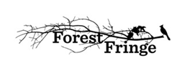

**“Welcome to the Fringe”**

**Artist Application Form**

|  |  |
| --- | --- |
| Name |  |
| Date of Birth |  |
| Current Residency |  |
| Residency / Passport type |  |
| Contact details | Mobile:  Telephone  Email address:  Website (if available):  Current Work (if available):  Job Title:  Level of English: |
| Brief description of your proposed work/ performance.  * Please also specify if it’s an online show to be performed live through video conference/internet, or face to face? |  |
| Brief Description of your company – group (if available) |  |
| Practical description of the show | (title, number of performers, duration, equipments required, props, costume etc…) |
| Please provide links for visual materials available about the proposed work/performance |  |
| Short statement of why you/your company would like to take part in “Welcome to the Fringe” |  |
| Please confirm that you can commit to the dates 20-25 August 2015 |  |